SUMMARY OF TRAFFIC SPEED AND VOLUME DATA

Somerset County Council Highways department supported a request to undertake traffic speed and volume readings on 3 roads in Beckington. These were Bath Road, Frome Road and Warminster Road.

The locations of the radar equipment are as shown in the diagram below.

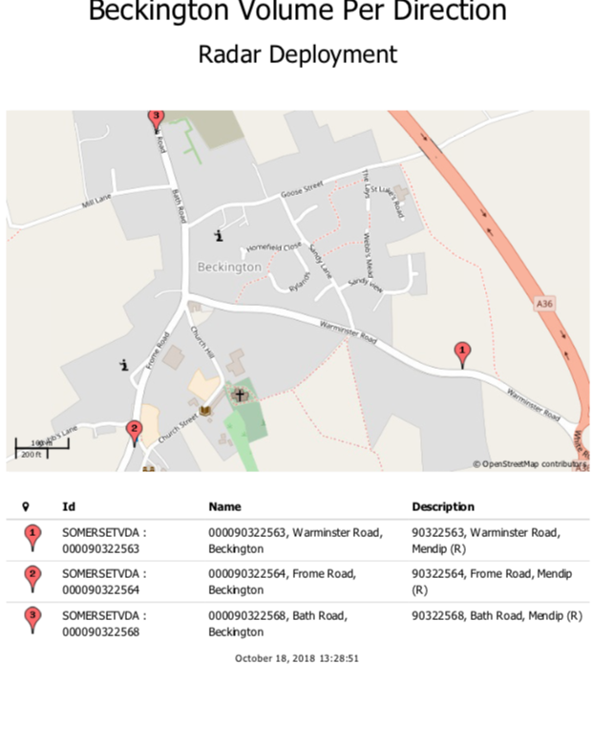
The survey was undertaken over a 14- day period from 12 Noon 6th September 2018 to 12 Noon 19th September 2018. Analysis of the data shows the following:

BATH ROAD (30 mph speed limit)

Volume

The total traffic count for both directions over the 14 -day period was 33379. This was an average of 2384 per day over a 7 -day week and 2704 per workday. Each day volume peaked on two occasions, during the morning at 8am and during the afternoon at 3pm.

Speed

The average mean speed of all vehicles was 24.7 mph.

The average speed during the am peak was 30.1 mph and pm peak 26.6 mph.

The number of vehicles exceeding the 30 mph speed limit during the 14 day period was 537, 1.6% of the total volume or an average of 2 cars every 125.

The breakdown of the speeds at which these vehicles were travelling is as follows: -

30 – 35 mph 424

35 – 40 mph 93

40 – 45 mph 15

45 – 50 mph 3

Over 50 mph 2

TOTAL 537

FROME ROAD (20 mph speed limit)

The total traffic count for both directions over the 14 -day period was 29225. This was an average of 2088 per day over a 7 -day week and 2400 per workday. Each day volume peaked on two occasions, during the morning at 8am and during the afternoon at 3pm.

Speed

The average mean speed of all vehicles was 27 mph.

The average speed during the am peak was 36.3 mph and pm peak 30.9 mph.

The number of vehicles exceeding the 20 mph speed limit during the 14 day period was 1874, 6.4% of the total volume or an average of 7 cars every 110.

The breakdown of the speeds at which these vehicles were travelling is as follows: -

20 – 25 mph 527

25 – 30 mph 649

30 – 35 mph 445

Over 35 mph 253

TOTAL 1874

WARMINSTER ROAD (30 mph speed limit)

Volume

The total traffic count for both directions over the 14 -day period was 17513. This was an average of 1251 per day over a 7 -day week and 1399 per workday. Each day volume peaked on two occasions, during the morning at 8am and during the afternoon at 3pm.

Speed

The average mean speed of all vehicles was 27.7 mph.

The average speed during the am peak was 31.3 mph and pm peak 28.7 mph.

The number of vehicles exceeding the 30 mph speed limit during the 14 day period was 418, 2.4% of the total volume or an average of 3 cars every 125.

The breakdown of the speeds at which these vehicles were travelling is as follows:

30 – 35 mph 334

35 – 40 mph 74

40 – 45 mph 9

45 – 50 mph 1

Over 50 mph /

TOTAL 418

CONCLUSIONS
- Bath Road and Warminster Road do not appear to be a major problem, with speeding traffic at 1.6% and 2.4% respectively.
- Frome Road is quite different, and the indication is that the 20mph speed limit is not impacting driving behaviour at all.
- The average peak times are 8am and 3pm.

RECOMMENDATIONS

- Share data with Avon & Somerset Police with a view to ensure focus of speed enforcement on Frome Road is at the relevant times.
- Consider a request to SCC Highways to reduce the length of the 20 mph speed restriction on Frome Road, and introduce 5 sets of 20 mph roundels, which will raise the awareness of the speed limit. Monitor after implementation.
- Encourage Community Speed Watch Group to undertake regular speed watch activity at peak times of the day.
- Consider purchasing a parish Speed Indicator Device (SID) that can rotate across the key roads in the village.
- Advise the PC to contact local long standing Speed Watch leads who will be able to advise on the benefits of a SID and community speed watch group.
- Share this data with the community

Councillor Linda Oliver

Mendip District Councillor; Rode & Norton St Philip Ward.
Somerset County Councillor: Frome North Division

