Mendip East Newsletter – February 2021.

Avon and Somerset Police

Welcome to our third monthly newsletter, which will be sent out from the team at the start of each month to keep you updated about what your local neighbourhood policing team have been up to and anything we have planned for the future – If you no longer wish to receive this please let us know.
We have now seen our local Facebook pages change these can now be found under: Frome Neighbourhood Policing and Mendip Neighbourhood Policing.
We have been facing new challenges with COVID restrictions, the weather but we are continuing to make sure people are safe.

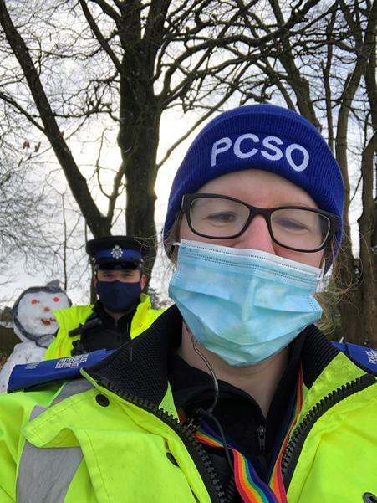

Shepton Mallet Town –

We are now fully into the winter season as best displayed by our recent Snow Day. Our homeless and elderly/vulnerable community are at most risk, Mendip Council recently posted out useful information in regards to cold weather provision. We have also put this information on our Neighbourhood policing pages and shared on our social media pages to promote this important information and multi-agency working. Our elderly/vulnerable people are also at risk at this time of year, so it’s important that we remain as visible within our communities to check on them and keep in contact with our sheltered housing officers for safeguarding concerns. If you have any safeguarding concerns for family members or neighbours please don’t hesitate to contact us or social services for further advice.

This month the Neighbourhood policing team have been out patrolling the town and open spaces. The vast majority of our local community have been adhering to the current lockdown rules helping everyone stay safe. This week due to the adverse weather, the team adapted to the situation and spent more time patrolling on foot in the park’s and open spaces. The team engaged with many walkers and children enjoying the open spaces, two PCSO’s came across a marriage proposal while patrolling and approached them to congratulate them. The special moment was captured by a local photographer to allow the couple to remember the occasion in these difficult times.

Frome Town –

Frome Neighbourhood Officers were called to reports of a number of youths with air weapons. As a result of these reports, officers were deployed to the area and targeted patrols were conducted. Shortly afterwards Officers located three youths in a wooded area with two air rifles in their possession. Subsequently the air rifles were seized from the youths and the investigation is currently ongoing.

The Frome Neighbourhood officers are also continuing their dedicated patrols around the parks and open spaces in Frome to tackle the recent increase in anti-social behaviour.

Frome and Shepton Rural-

The Frome and Shepton Rural teams have seen an increase in rural thefts, the thefts have included burglaries at our local Public Houses.
During the evening of Tuesday 19th January, officers from the Mendip East Neighbourhood Policing Team, supported by officers from the Force Rural Affairs Unit conducted high visibility patrols in and around Frome and Shepton Mallet, specifically focusing on poaching and thefts. The teams are dedicated to tackling rural crime and will be patrolling and visiting public houses within out area over the coming weeks to offer crime prevention advice and reassurance.

If anyone experiences any attempted break-ins Thefts or suspicious activities it is very important that those affected to calls 101 to report this – this is very helpful to us so we can plot where crime is happening and assist in planning future operations.
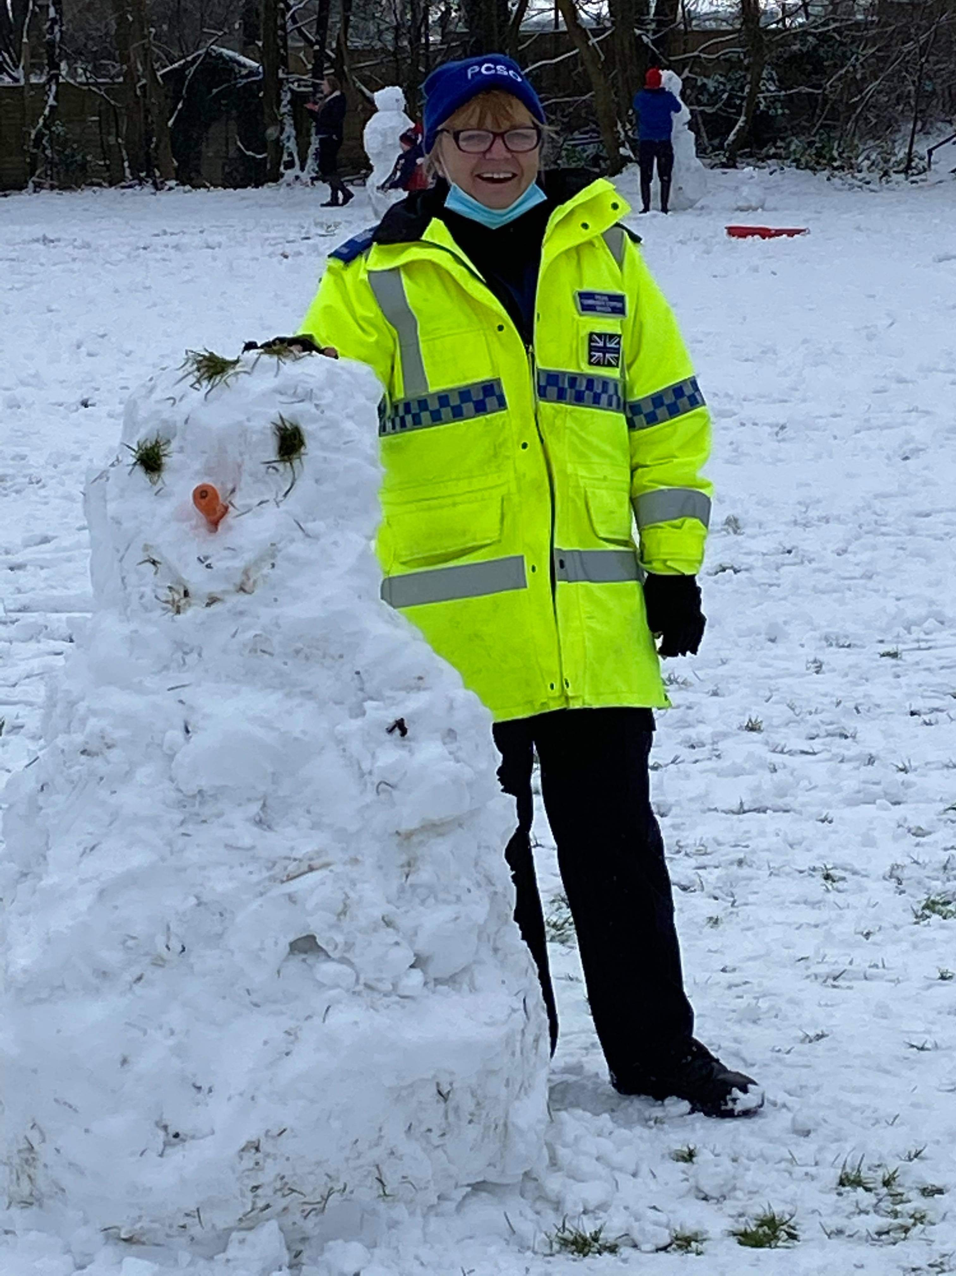

Across the Mendips we have not had any significant COVID breaches.

We continue to ask that members of the public who are witnessing any incidents to report them to us as they are happening, via 999, 101 or the Force Website.

