Mendip East Newsletter – April 2021.

Avon and Somerset Police

Welcome to this month’s newsletter, this will be sent out from the team at the start of each month to keep you updated about what your local neighbourhood policing teams have been up to and anything we have planned for the future – If you no longer wish to receive this please let us know.
We have now seen our local Facebook pages change these can now be found under: Frome Neighbourhood Policing and Mendip Neighbourhood Policing.
We are still facing challenges with covid restrictions and we are continuing to make sure people are safe.

Lockdown rules changed on the 29th March 2021.
You can now meet outdoors either in a group of six (from any number of households), or in a group of any size from up to two households (each household can include existing support bubbles, if eligible)
•You can take part in formally organised outdoor sports with any number of people (outdoor sports venues and facilities can reopen)
•Childcare and supervised activities are allowed outdoors for all children
•Formally organised parent and child groups can take place outdoors for up to 15 attendees. Children under five will not be not counted in this number
•The ‘stay at home’ rule ends, but many restrictions remain in place. People should continue to work from home where they can and minimise the number of journeys they make where possible. Travel abroad continues to be prohibited, other than for a small number of permitted reasons.

We continue our approach, where we engage, explain, encourage and enforce where necessary.

Frome Town –

Another busy month for the Frome town team, with changing legislation for COVID rules and slightly better weather we saw a rise in the numbers of residents out and about. Schools have now gone back much to the relief of many parents and the team have been meeting both children and parents outside the schools to ensure social distancing and to ensure that the children can arrive safely when being dropped off and picked up, we’re also engaging with the schools by means of interventions and lesson plans. The team has made a significant arrest of a male suspected of committing an Arson Bin Fire in the Badcox area and enquiries are still ongoing, there have also been some arrests for drug offences in Frome with court action as a result.

Looking forward there are more changes with Covid regulations on April 12th so the team are also working hard with all licensed premises, to ensure that the licensing objectives are met and customers and staff remain safe.

Frome and Shepton Rural-

Over the last few weeks we have been made aware about incidents at Downside School, Stratton on Fosse. There have been incidents of graffiti and Anti-Social Behaviour directed towards the pupils while on the school grounds, specifically on the playing fields.
To try and combat these the neighbourhood team have met with the head teacher from the school, to assist with tackling the increase in incidents we will be patrolling the school and it’s grounds on a regular basis, dealing with offenders positively.

Last week Frome Rural Neighbourhood team successfully seized a motorbike with links to wider county lines. We strive to disrupt the drug supply chain by removing the means of transportation from county lines gangs in our area and beyond. Furthermore, we are working to remove a second vehicle from county lines gangs that we hope to return to the registered keeper.
The Frome rural neighbourhood team are continuing with their targeted fly-tipping patrols in the Berkley Lane, Gypsy Lane and Lullington areas. We have begun to see a noticeable reduction in fly-tipping incidents. We encourage the public to use the "Fix My Streets" app to help report fly tipping locations. This helps get reports directly to the teams responsible for removing it. Find further details at: https://www.fixmystreet.com.

Shepton Mallet Town –

With the stay at home regulations relaxed we see it prudent to share with you some car safety information, particularly for those of you visiting attractions in and around Somerset.
Here is some crime reduction advice ideas to reduce you becoming a victim.
Catalytic converters are targeted because of the precious metals that they are made with, namely rhodium, platinum and palladium. Thieves simply cut the catalytic converter from the exhaust pipe of a parked car and sell them on to scrap metal dealers. Taller vehicles are more vulnerable as the catalytic converters are easier to access.
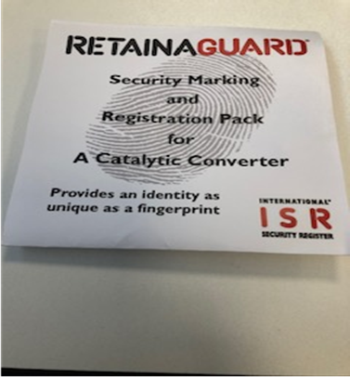
To reduce the risk of having your catalytic converter stolen you could
1. Park to restrict access to the underneath of the car
2. Ask your dealer to weld the catalytic converter to the car
3. Fit a tilt alarm
4. Purchase anti-theft products, such as a cage clamp
5. Register your converter and mark it with a forensic marker, which will make it harder for thieves to dispose of

For more information on catalytic converter theft, have a look at this BBC One Inside Out Catalytic Converter Theft video from March 2020.
We will be contacting those that have already have been victims of this crime and delivering a Security Pack.

Thank you for your continued support and we wish you all a safe and Happy Easter.

Mendip East Neighbourhood Supervisor Contact details:

Sergeant Rachel Clark
Work mobile: 07889655571
Email: Rachel.clark@avonandsomerset.police.uk

PCSO Supervisor Stephen Reading
Work mobile: 07702113808
Email: Stephen.reading@avonandsomerset.police.uk

We continue to ask that members of the public who are witnessing any incidents to report them to us as they are happening, via 999, 101 or the Force Website.

