Mendip East Newsletter – January 2021.

The Mendip East Neighbourhood Policing Team would like to wish you all a Happy New Year.
Welcome to our second monthly newsletter, which will be sent out from the team at the start of each month to keep you updated about what your local neighbourhood policing team have been focusing on throughout December – If you no longer wish to receive this please let us know.
Your local Neighbourhood Policing teams Facebook pages are now live and these can now be found under: Frome Neighbourhood Policing and Mendip Neighbourhood Policing (Serving Shepton Mallet, Wells, Street and Glastonbury) please share and follow.

Frome Town –

The Frome Neighbourhood team have focused on tackling an issue of untaxed vehicles parking on the highway in and around the Marston Trading Estate. The team have worked closely with the DVLA to identify the vehicles and the locations of where the vehicles have been park, this led to 7 vehicles being clamped and 4 being seized by the DVLA. This is a positive result from the reports made to us by local residents.

The team have had to concentrate their efforts on the Frome open spaces again this month due to a small number of youths causing anti-social behaviour. They have utilised dispersal powers within Victoria Park and Mary Bailey playing fields, and alcohol has been seized. Sergeant Rachel Clark and PCSO Gary Maule recently met with local school head teachers, Frome Town Council and Young Somerset to discuss diversionary options going forward. The team will continue to conduct regular patrols of the open spaces and deal with any anti-social behaviour positively. We would like to remind the Public to report any incidents that they witness.

Frome and Shepton Rural-

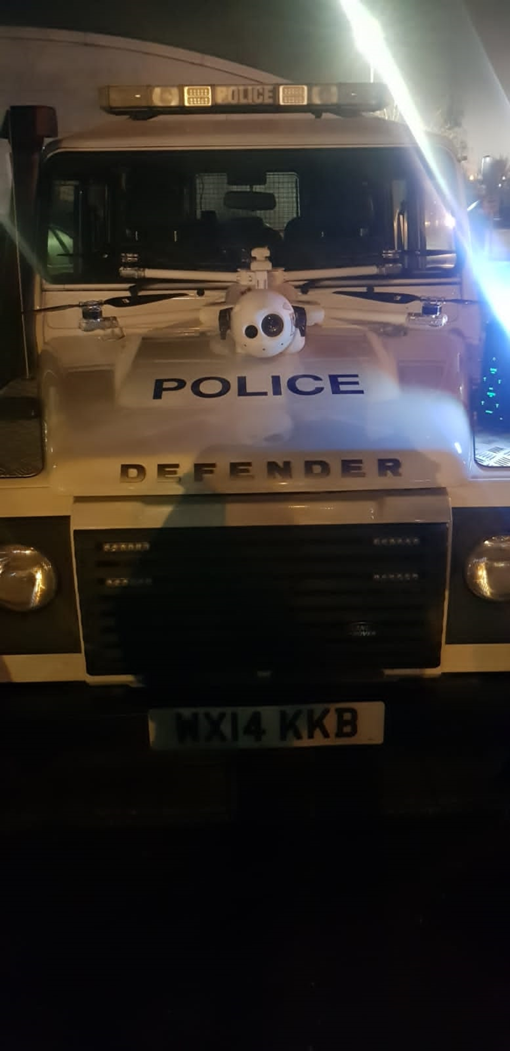
The Frome and Shepton Rural Neighbourhood team would like to thank all the Farmers who have been reporting poaching and rural thefts they have been experiencing. These reports have helped us to help you, due to the intelligence gained from reports we were able to secure the assistance from the Avon and Somerset’s force drone team the “eye in the sky”. The drone was deployed over the rural skies of Frome to deter and capture evidence of poachers, the height gave us an advantage to see over far wider areas that ground units alone could patrol. During this latest day of action we have been also to sign up as number of farms to the Farm Watch Scheme who previously did not receive text alerts.

During December the team have also been busy visiting Christmas tree farms and outdoor retail farm shops offering festive crime prevention advice.

Shepton Mallet Town –

Throughout December the Shepton Mallet PCSO’s have been running a Christmas Crime Prevention Campaign and have been focussing on Fraud and online shopping scams, they have also focussed on elderly people receiving COVID-19 scams. The team have created multiple leaflets and put them in all our prominent local shops and they have also been visiting local cafes and handing them out to our members of public. They have held beat surgeries using the community contact vehicle and utilised our social media platforms to promote this. They have also given the leaflets to the local neighbourhood watch schemes so they in turn can give out this information to their elderly/vulnerable neighbours on their schemes. As a team they also attended local sheltered housing communities to post this information to the elderly residents.

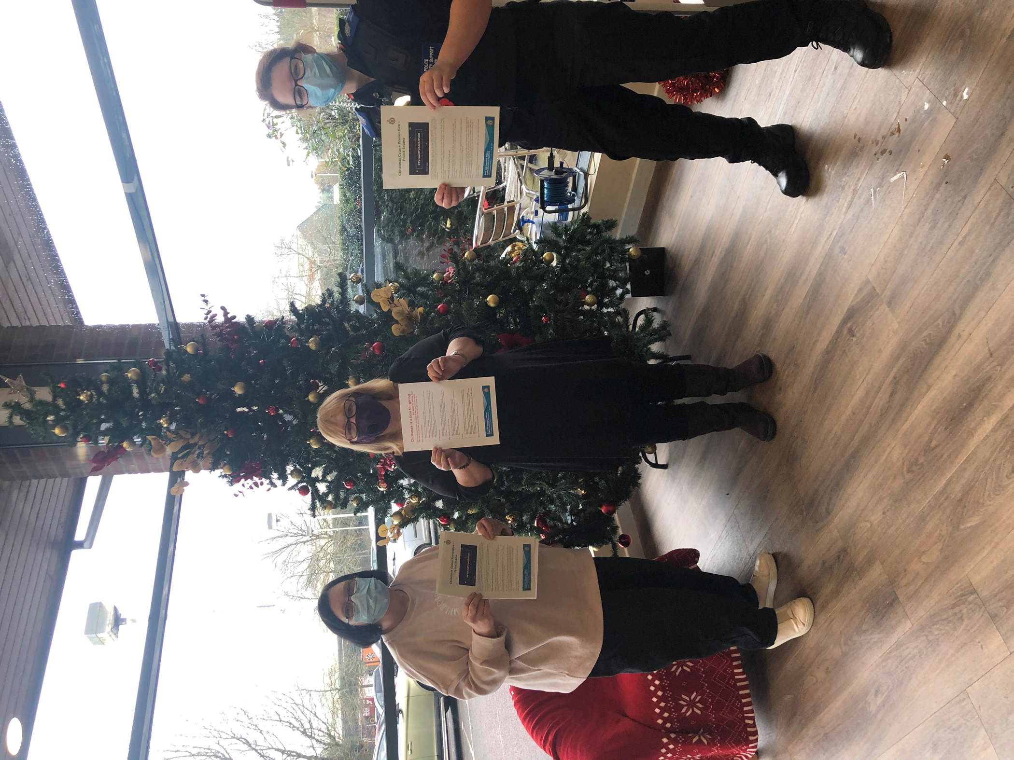

We continue to ask that members of the public who are witnessing any incidents to report them to us as they are happening, via 999, 101 or the Force Website.

